CO3 ASSESSMENT TOOL 2 CASE STUDY BASED ASSESSMENT

CSA0652-Design and Analysis of Algorithms for Complexity Analysis.

DONE BY:
Name: J.VVINAY KAILASH A.M
Reg No: 192424062
SIMATS Engineering

Supervisor:
Dr. MARY HARIN FERNANDEZ , Professor
Dr. S. PRADEEP KUMAR, Professor

Question 1: Airport Flight Lookup System (Binary Search)

Source Code (binary_search_flight_lookup.py)

def binary_search(flights, target):
low = 0
high = len(flights) - 1

while low <= high:
mid = (low + high) // 2

if flights[mid] == target:
return mid

elif flights[mid] < target:
low = mid + 1

else:
high = mid - 1

return -1
flights = [101, 105, 110, 115, 120, 125, 130, 135]

target = 120

result = binary_search(flights, target)

if result != -1:
print("Flight found at index:", result)
else:
print("Flight not found")
Output:
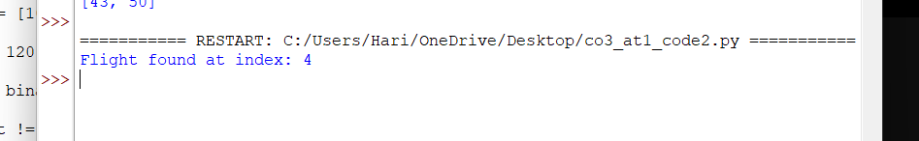

Report
Problem Analysis
Airport systems must retrieve flight records quickly for passenger assistance.
Requirements
- Flight records stored in sorted order
- Fast response time
- Accurate search results
- Scalability for large datasets
Divide and Conquer Approach
- Find middle flight number.
- Compare with target flight.
- Search left or right half.
- Repeat until found.
Time Complexity
- Best Case: O(1)
- Average Case: O(log n)
- Worst Case: O(log n)

Question 2: Enterprise Search and Sort Pipeline (Merge Sort + Binary Search)

Source Code (merge_sort_binary_search.py)
def merge_sort(arr):
if len(arr) > 1:
mid = len(arr) // 2

left = arr[:mid]
right = arr[mid:]

merge_sort(left)
merge_sort(right)

i = j = k = 0

while i < len(left) and j < len(right):
if left[i] < right[j]:
arr[k] = left[i]
i += 1
else:
arr[k] = right[j]
j += 1
k += 1

while i < len(left):
arr[k] = left[i]
i += 1
k += 1

while j < len(right):
arr[k] = right[j]
j += 1
k += 1
def binary_search(arr, target):
low = 0
high = len(arr) - 1

while low <= high:
mid = (low + high) // 2

if arr[mid] == target:
return mid
elif arr[mid] < target:
low = mid + 1
else:
high = mid - 1

return -1

documents = [45, 12, 89, 34, 23, 67, 90, 11]

merge_sort(documents)

print("Sorted Records:", documents)

target = 67

result = binary_search(documents, target)

if result != -1:
print("Document found at index:", result)
else:
print("Document not found")
Output:
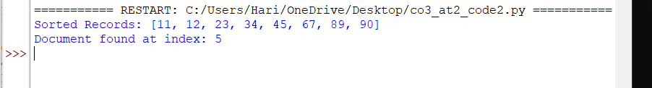

Report
Problem Analysis
Enterprise systems handle large document collections. Records must be sorted before performing frequent searches.
Issues Identified
- High indexing cost
- Large-scale datasets
- Frequent search queries
- Need for scalability
Integrated Solution
Stage 1: Merge Sort
- Sort all records efficiently.
- Uses Divide and Conquer.
- Splits data into smaller parts and merges them.
Stage 2: Binary Search
- Searches the sorted records.
- Repeated queries become very fast.

Time Complexity

Operation | Complexity
Merge Sort | O(n log n)
Binary Search | O(log n)
Combined | O(n log n) + O(log n)

Why This Solution?
- Merge Sort efficiently handles large datasets.
- Binary Search provides rapid retrieval.
- Suitable for enterprise-scale systems.
- Highly scalable and reliable.

